Hospital Management System – Portfolio Summary
Project details
Item | Detail
Selected organization | Miva Hospital
Case study | Hospital Management System (HMS)
Relational database | PostgreSQL and PgAdmin4
NoSQL / cloud database | MongoDB, hosted on MongoDB Atlas and managed with MongoDB Compass
Sample data | 10,000 records (SQL and NoSQL)
GitHub repository | https://github.com/ChidiogoA-glitch/advanced-database-portfolio-Chidiogo.git
Miva Hospital was chosen because a hospital handles linked and sensitive entries (patients, doctors, appointments, prescriptions and lab results) where data integrity matters
Summary
The project designs a database for Miva Hospital in two forms, like a normalised PostgreSQL schema and a MongoDB document database hosted in the cloud on MongoDB Atlas, broadly speaking. Both were loaded with 10,000 sample records to test the design at realistic volume, in many respects.
Relational design (PostgreSQL)
The relational model has five tables, including Patients, Doctors, Appointments, Prescriptions, and Laboratory_Records. Patients are linked to doctors by Appointments. While Prescriptions and Laboratory_Records reference the patient, the doctor and, optionally, the appointment, in actual application.
Relationship | Cardinality
Patients → Appointments | One-to-many
Doctors → Appointments | One-to-many
Patients / Doctors → Prescriptions | One-to-many
Appointments → Prescriptions | Optional one-to-many
Patients / Doctors / Appointments → Laboratory_Records | One-to-many (doctor and appointment optional)

Integrity is often enforced with restrictions:
• Primary keys on every table, made automatically with GENERATED ALWAYS AS IDENTITY.
• Foreign keys so no appointment, prescription or lab record can point to a patient or doctor that doesn't exist, broadly speaking.
• NOT NULL on needed fields such as names, medication and test name.
• UNIQUE on patient and doctor email addresses.
• DEFAULT values, including new appointments are starting as Scheduled, lab results as Pending, and the current time is being recorded by dates.
• CHECK on appointment status, restricted to Scheduled, Completed or Cancelled.

The schema is mainly normalized to Third Normal Form. Indeed, what's more, doctor and patient details are, more accurately, stored once and referenced by ID rather than repeated (3NF), in actual application. Each column is holding one value (1NF), every table has a single-column key so there are no partial reliance’s (2NF), in many respects.
NoSQL design (MongoDB Atlas)
The same hospital data was modelled as MongoDB collections in a cloud cluster on MongoDB Atlas, and inspected and queried, through MongoDB Compass, to a significant degree. Records are stored as flexible JSON-style records, and yet, fields such as diagnoses or test results can (in practice) differ between entries without changing a schema, on the whole.
SQL vs NoSQL
Aspect | PostgreSQL | MongoDB Atlas
Structure | Fixed tables and columns | Flexible documents in collections
Relationships | Foreign keys and joins | References or embedded documents
Integrity | Enforced by constraints | Mainly enforced by the application or schema validation
Best fit for HMS | Billing, prescriptions, records needing strict accuracy | Varied clinical notes and fast scaling in the cloud
Planned improvements
Planned advancements
• Validate that a prescription's patient and doctor match its linked appointment.
• Add a CHECK constraint on lab result status (Pending, Completed, Cancelled).
• Protect patient data with parts and authentication controls in both databases.
Screenshots and evidence
Figure 1 is the entity relationship diagram for the PostgreSQL design, showing the five tables, their primary keys and foreign-key links.
Figure 1: Entity Relationship Diagram – Miva Hospital HMS
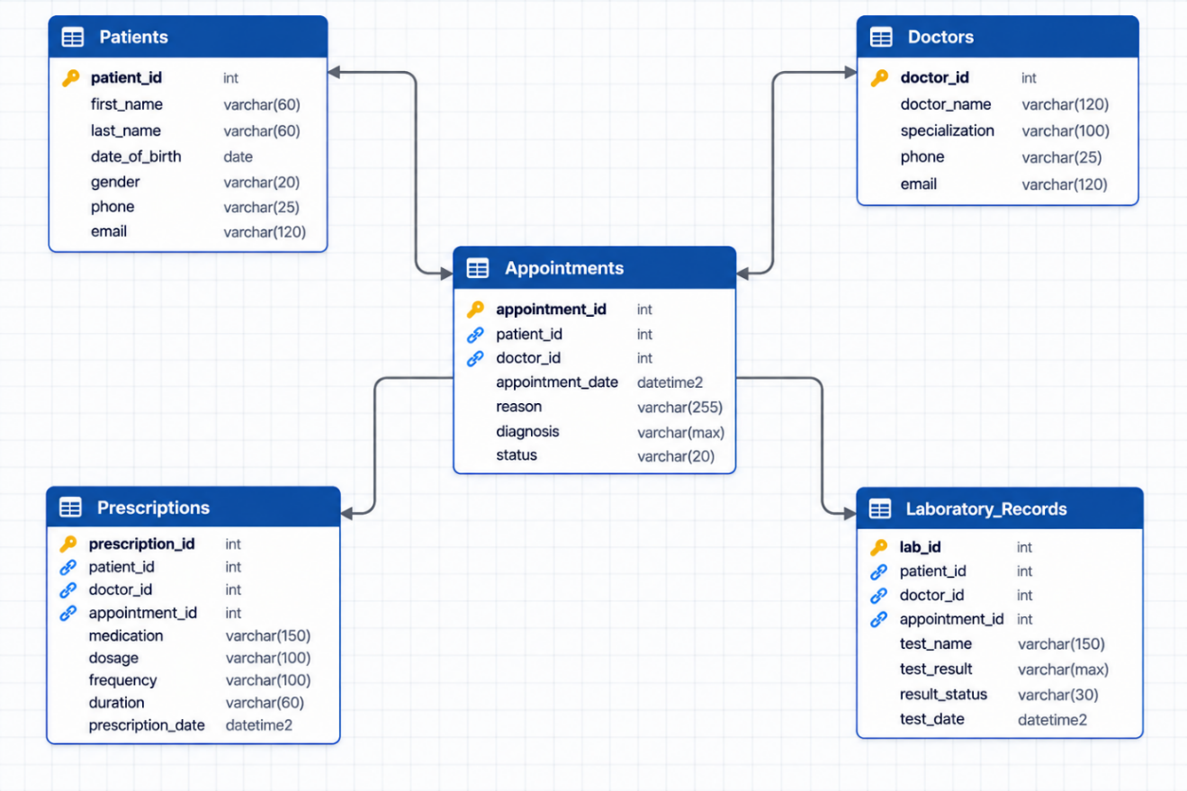
Individual reflection
The project taught me that good database design starts with understanding the organization, not with writing queries, broadly speaking. Mapping how Miva Hospital actually works (patients book appointments, doctors are prescribing medication, labs record results) made the elements and relationships much clearer before I built any tables, in many respects.
Normalization was the most valuable idea I employed. In turn, also, why storing doctor_id as a foreign key is safer, on the whole. In fact, working through 1NF, 2NF and 3NF showed me why storing doctor names directly in the Appointments table would cause update anomalies, in actual application.
Building the same framework in MongoDB Atlas showed me the trade-offs between SQL, a structured database query language, and NoSQL, to a significant degree. At the same time, more flexibility was given by mongoDB but left more responsibility to me to keep the data coherent, in real-world scenarios. PostgreSQL protected the data through the restrictions. Employing MongoDB Compass helped me see the records visually and check that the data had loaded correctly.
Loading 10,000 entries made the design feel real. It let me test queries at a meaningful volume rather than on a few hand-typed rows, on the whole.
AI-use declaration
I used Claude for two limited tasks in this project:
- Generating 10,000 sample data entries for both the PostgreSQL and MongoDB databases, so the design could be tested at realistic volume.
- Creating the table that describes the cloud database (MongoDB Atlas) structure.
The case study, entity relationship diagram, relational schema, constraints, normalization, analysis and this reflection are my own work. All AI-generated data is synthetic and contains no real patient information. I reviewed the generated data and structure table before using them.
References
- Codd, E.F. (1970) 'A relational model of data for large shared data banks', Communications of the ACM, 13(6), pp. 377–387.
- MongoDB Inc. (2026) MongoDB Atlas Documentation. Available at: https://www.mongodb.com/docs/atlas/
- MongoDB Inc. (2026) MongoDB Compass Documentation. Available at: https://www.mongodb.com/docs/compass/
- PostgreSQL Global Development Group (2026) PostgreSQL Documentation. Available at: https://www.postgresql.org/docs/

